## 2.3.2 Build List

### 2.3.2.1 Purpose

* Build list displays all current builds for the selected game
* The user is able to select a current meta build
* This helps get the user closer to figuring out the strat they want to use for their game
* This screen can be navigated to through the game list screen.
* The user can navigate the menu, or builds from this screen  
  2.3.2.2 Wireframe Screenshot  
  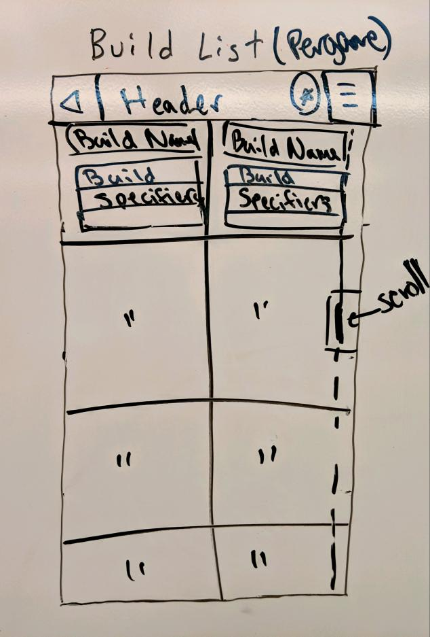  
  2.3.2.3 Mockup Screenshot  
  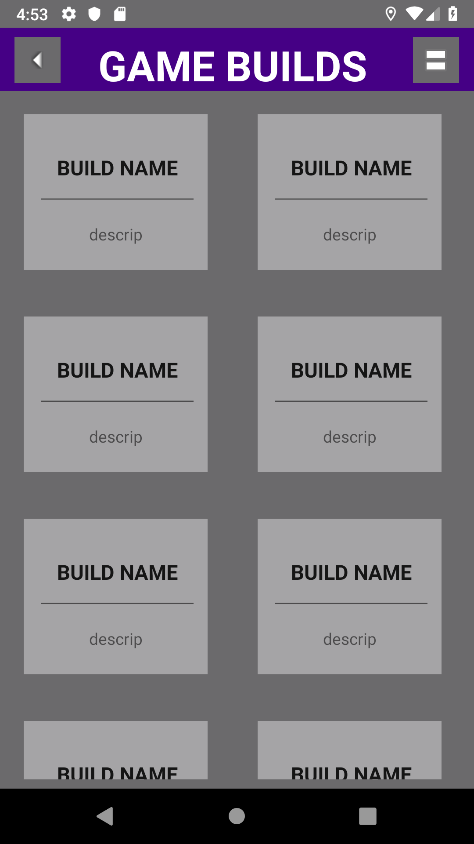

### 2.3.2.4 Prototype Screenshot Screenshot of prototype for this interface goes here.

### 2.3.2.5 Design Commentary

Talk about how your UI changed as it went through the steps of Wireframe -> Mockup -> Prototype. What did you like / dislike at each stage that influenced the next round of UI development?